|  |  |
| --- | --- |
| EXERCICES | POINTS |
| Exercise 1 | 10 |
| Exercise 2 | 10 |
| Exercise 3 | 30 |
| Exercise 4 | 50 |
| **TOTAL** | **100** |

**Exercise 1: Boolean expression**

Demonstrate these equalities using the 7 simplification rules you have learnt.

1. (A or B or C) and (!A or B or C) = B or C

= (A or !A) and (B or C)

= True and (B or C)

= B or C

So: (A or B or C) and (!A or B or C)= B or C

1. (A and B) or (!A or !B) = True

= ( A and B) or !(A and B)

= True

So: (A and B) or (!A or !B)= True

**Exercise 2: Truth table**

1. **A and (A or B)**

|  |  |  |
| --- | --- | --- |
| **A** | **B** | **A and (A or B)** |
| True | True | True and (True or True)=True |
| True | False | True and (True or False)=True |
| False | True | False and (False or True)=False |
| False | False | False and (False or False)=False |

A and (A or B) = …(A and A) or (A and B)

= True or (A and B)

= (A and B)

1. **(A and B) or !C or [C and (!A or !B)]**

|  |  |  |  |
| --- | --- | --- | --- |
| **A** | **B** | **C** | **(A and B) or !C or [C and (!A or !B)]** |
| True | True | True | (True and True) or !True or [True and !(True or True)]=True |
| True | True | False | (True and True) or !False or [False and !( True or True)]=True |
| True | False | True | (True and False) or !True or [True and !(True or False)]=True |
| True | False | False | (True and False) or !False or [True and !(True or False)]=True |
| False | True | True | (False and True) or !True or [(True and !(False or True)]=True |
| False | True | False | (False and True) or !False or [(False and !(False or True)]=True |
| False | False | True | (False and False) or !True or [(True and !(False or False)]=True |
| False | False | False | (False and False) or !False or [(False and !(False or False)]=True |

(A and B) or !C or [C and (!A or !B)]= [(A and B) or C] or [ !C and (!A or !B)]

=[(A and B) or C] or [!C and !(A and B)]

=[(A and B) or C] or ![ C or (A and B)]

=True

**Exercise 3: Ranges**

1. **Simplify** the expressions
2. a < 3 or a > 3

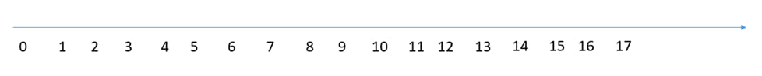

1. a >5 or a < 6
2. a > 2 and a > 12



1. a >= 8 or a > 8



1. a >=0 and a <= 0



1. Draw the shape corresponding to the boolean expression
2. (x = y)

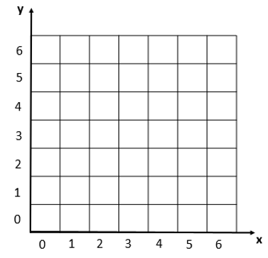

1. (x>2) and not((x>3 and x<4) and (y>2 and y<6))



1. Write the boolean condition for this grid

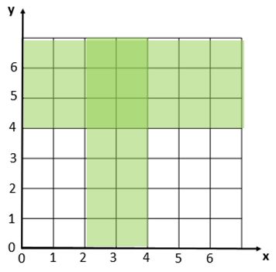

Expression: (x>2 and y<4) or y>4

**Exercise 4: Flowcharts**

1. Draw the tree of conditions

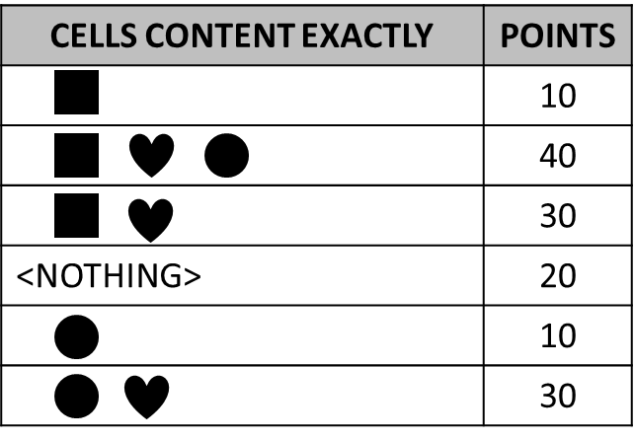

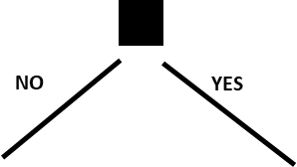

20

10

30

10

30

40

0

0

1. Say what I do thanks to the flowchart below?
   1. It is Monday, it’s hot and I have homework. What I do?

Work

* 1. It’s Sunday, it’s cold, it’s not raining, I don’t like bicycle and I’m not tired. What I do?

Watch movie

* 1. It’s Friday, it’s cold and raining, I’m tired but I don’t have homework. What I do?

Sleep

* 1. When do I ride my bike? **Give a boolean expression**

It’s not on the weekend,it’s hot and don’t have homework and like ride bicycle.

It’s on the weekend, it’s cold and not raining and like ride bicycle.

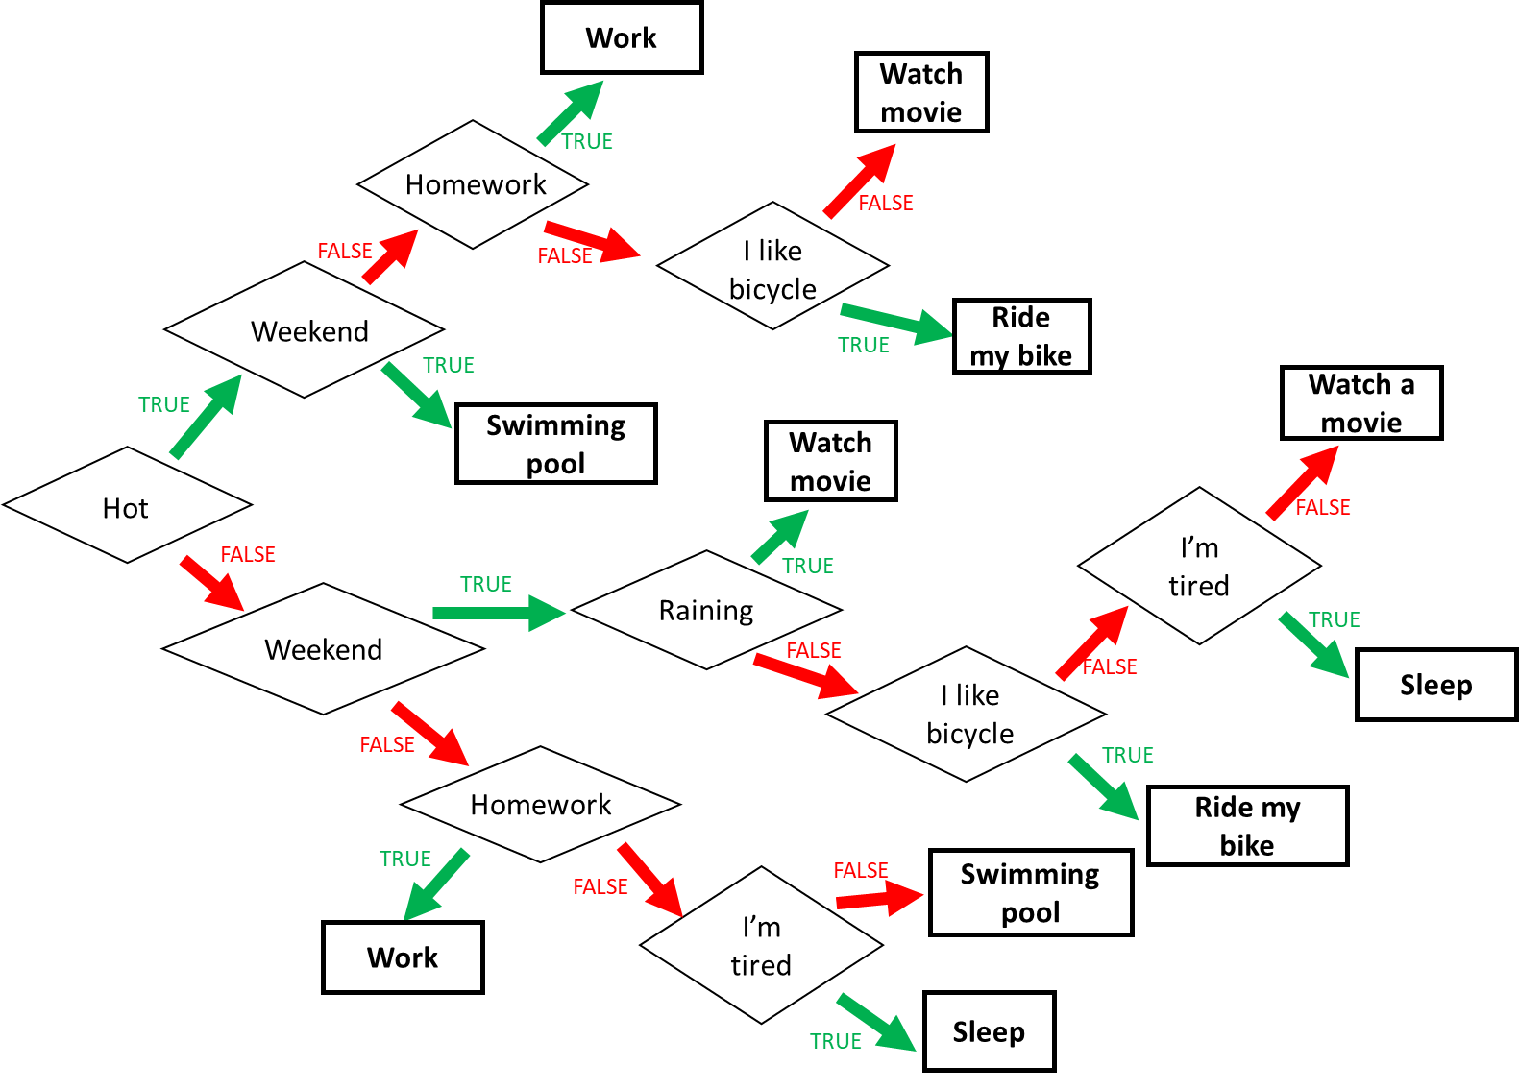

1. Find the boolean expression of **RED** of this flowchart

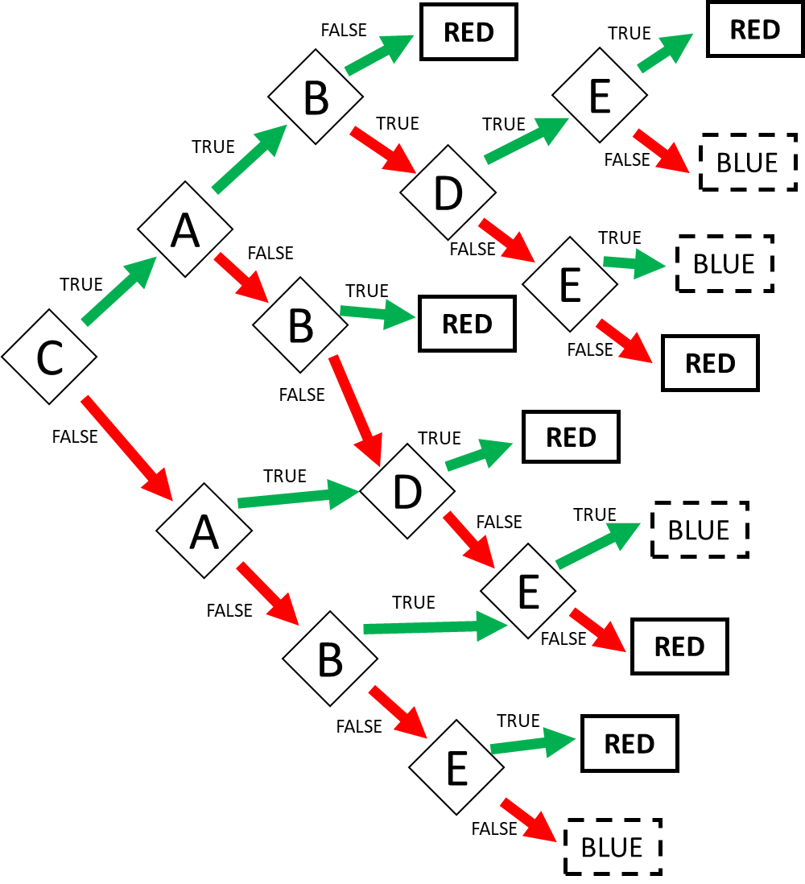

Expression: RED = CAB or CA!BDE or CA!B!D!E or C!AB or !CAD or !C!AB!E or !C!A!BE